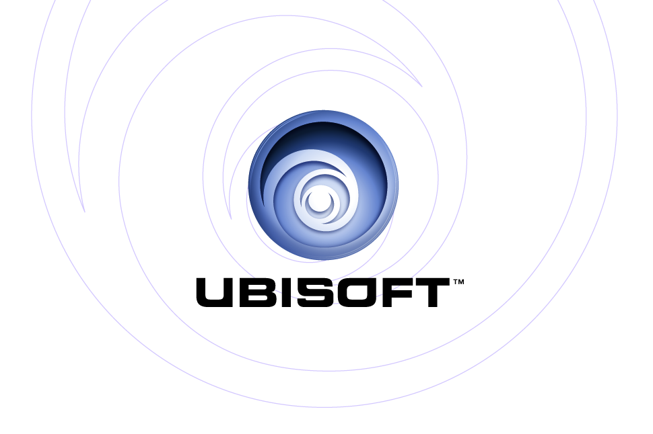
PRESENTS: | PC CD-ROM
Silent Hunter® III

Product Description

Command the cunning and deadly U-boats of the North Atlantic and experience the tension-filled atmosphere of a WWII submarine movie. The king of submarine simulations returns with an all-new 3D game engine, new crew-command features, and more realistic action than ever before. The game includes a career campaign, a dynamic campaign, patrols that have both fictional and historical missions, a mission editor and multiplayer feature. Whether it is stalking convoys or dodging depth charges, players will experience their own personal war story. The spectacular graphics, multiplayer options and suspenseful gameplay combine to create the most impressive submarine simulation ever.

Key Features

- Realistic and immersive environment
The suspense-filled atmosphere includes realistic 3D water modeling, day/night cycles, historically accurate subs, ships and aircraft. The detailed U-boat interiors, changing weather effects and engaging audio represent the ultimate in WWII submarine warfare.

- A deadly array of U-boats and weapons
Playable U-boats include type II, VII, IX, and XXI submarines. Take aim against Allied convoys and warships. In recreating the great submarine battles of WWII, players will hide in silence just below threatening escort ships, fire deadly torpedoes or surface and pound enemies with the deck gun.

- Accessible to players of all skill levels
Includes a 3D interface – what you see is what you use. Players will experience a simplified learning curve that will be easier to handle than standard simulations. Use the naval academy tutorial to learn the basics. The realism settings are customizable to appeal to a variety of WWII combat fans.

- Command your crew
The crew will take orders and their behavior will evolve based on the results of each patrol. Commanders must consider morale and fatigue in decision making. A reward system will advance rank, elevate skills and bestow medals for achievement.

- Multiplayer with both cooperative and competitive modes for up to four players on the Internet
Join a wolfpack with other live players and take aim against intelligent AI-controlled opponents. Test your skills against other players to determine the ace commander.

Product Specifications:
Publisher: Ubisoft
Developer: Ubisoft Romania
Ship Date: February 2005
Category: Combat Simulation
Rating: Teen

